✅ Types of DNS Servers:
# Source: Chatgpt (GPT-5-Mini) at [1/18/2026]
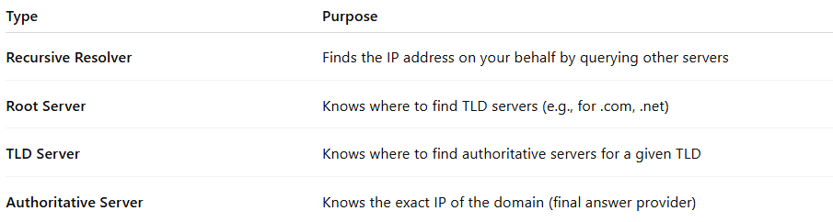

Type | Purpose
Recursive Resolver | Finds the IP address on your behalf by querying other servers
Root Server | Knows where to find TLD servers (e.g., for .com, .net)
TLD Server | Knows where to find authoritative servers for a given TLD
Authoritative Server | Knows the exact IP of the domain (final answer provider)

